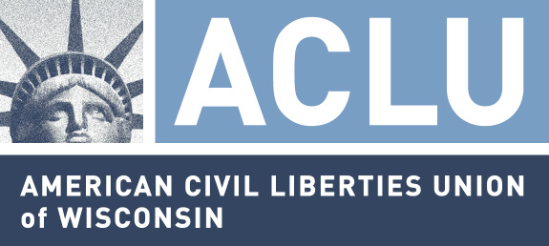

207 East Buffalo Street, Suite 325
Milwaukee, WI 53202-5774

March 1, 2010

Senator Russell Decker
Room 211 South
State Capitol
P.O. Box 7882
Madison, WI 53707-7882

Via facsimile to (608) 267-9027

Dear Senator Decker,

I am writing on behalf of ACLU members in the 29th State Senate District and throughout Wisconsin to encourage you to schedule a Senate vote on Senate Bill 25/Assembly Bill 35. These bills address the issue of diminished educational opportunity for Native American public school students resulting from discriminatory race-based school team nicknames, logos and mascots. Last Thursday the Assembly passed an amended version of Assembly 35 with bipartisan support. The American Civil Liberties Union of Wisconsin testified in support of SB25/AB35 at a public hearing nearly a year ago. We support the amended version passed by the Assembly.

You undoubtedly believe that the State Senate’s deliberative powers are at least as great as the Assembly’s. In this instance, I hope that you’ll admit that the Assembly has crafted a compromise that addresses the issue at the same time that school districts are given a more than adequate mechanism to respond to complaints regarding their team nicknames. Representatives Soletski, Staskunas, Hraychuck, and Vruwink among others acted wisely, although many citizens misunderstand the purpose of this bill.

As we testified and have stated repeatedly, the ACLU of Wisconsin supports this legislation because it addresses educational opportunity. SB25/AB35 is about discrimination, not political correctness. Race-based nicknames may be offensive to some people and not to others. Offense is not the point. I suspect you know that the ACLU has long supported the right of citizens to freedom of expression, especially when speech is controversial or even hateful.

When the ACLU of Wisconsin was part of the litigation team seeking an injunction against violent conduct at boat landings during spear-fishing season many years ago the difference between conduct and speech arose. At a hearing in Wausau federal Judge Crabb asked us if our clients wished to enjoin hateful speech, such as “the only good Indian is a dead Indian.” We answered absolutely not. We wanted to enjoin conduct.

Likewise the government, in this case public schools, may not discriminate on the basis of race, ethnicity or national origin, gender, religion and other protected classes. Using a race-based nickname is not prima facie evidence of illegal discrimination. However, it does strongly suggest that the school district may not be providing equal opportunity for Native American students. For generations some schools have discriminated against Native American students. AB35 as amended gives public schools a fair chance to explain how their race-based nicknames are not discriminatory. Race-based nicknames, logos and mascots must not be allowed to contribute to discrimination, which harms our children.

Please let me know how you intend to advance this important legislation.

Thank you.

Sincerely yours,

Christopher Ahmuty
Executive Director

